**Black Professionals in IT: Productivity Despite Barriers**

Jeevan D. Hall

Department of Pan-African Studies, California State University of Los Angeles

PAS 4950: Senior Capstone Literature Review

Dr. Lawson Bush

Dec 10, 2021

**Introduction**

According to Congressman Markwayne Mullin, “America has been known as the land of opportunity.  Millions of immigrants left their own homes to find something in our country not readily available in their own: an opportunity to succeed. A large part of that success is defined by having a job. ” However, unfortunately Black people born here face many adversities in a myriad of career fields, especially within Information Technology (IT). Lack of trust, upward mobility, and equality stems from management at various IT firms nationwide (Trauth 2017). These firms detract from Black advancement, performance, and innovation because of restrictive hiring processes, systematic bias, and a lack of active, diverse recruitment. Information Technology hires Black people disproportionately to the overall United States population. Multiple factors contribute to the underrepresentation of Black males. Some include a lack of access to technology for Black youth, the absence of an early introduction to the subject in primary and secondary school, and a dearth of mentoring support groups pushing for the advancement of Black people in the technology industries. Few entities challenge the systematic bias or structural impediments (poverty, racism, microaggressions, lack of socio-economic mobility, a failed educational system, etcetera) limiting Black education and exposure to STEM professions.

To gain insight into the nature of Black male Professionals in IT, one must recognize the schooling, social environment, and reality of Black males. The Black experience within IT arrives only after many problematic social issues that shape Black males. These issues include learning from an educational system created to fail Black males, the perpetuation of the Black ignorance stereotype in Mathematics and Science, structural racism, social impediments for Blacks in the professional realm, and ultimately the school to prison pipeline. Black people in America must navigate seemingly insurmountable odds to improve their career trajectory and life. This literature review dissects popular notions regarding the Black presence in the IT profession. Furthermore, it highlights Black achievement despite structural barriers and obstacles to entry in the IT field (including myself). Overcoming obstacles and maintaining a high level of productivity in the workplace presents a significant and efficacious example of how inclusivity and diversity cultivates a more exceptional workplace.

In the context of this paper, microaggression refer to a statement, action, or incident regarded as an instance of indirect, subtle, or unintentional discrimination against members of a marginalized group such as a racial or ethnic minority. They may stem from the party communicating bias towards a Black person. This party may not even be aware that their comments are racist or biased.

**Conceptual/Theoretical Framework**

Some members of US society subscribe to simplistic notions of stereotypes regarding Black people, especially Black males. To debunk these false notions concerning Black males we will utilize three critical lenses: Critical Race Theory (CRT), the Individual Differences Theory of Gender & IT, and Pierre Bourdieu’s Capital Theory. According to Margret Zamudio, Critical Race Theory foregrounds race as the central construct for analyzing inequality (Zamudio 2008). CRT recognizes the intersection of race, gender, and class in understanding the toxic patriarchy, racism, and sexism framed within societal structures. This theory also provides a vital understanding of how our country's educational, professional, and governmental systems developed into the institutions they are today. The second lens utilized throughout this literature review includes Penn State Professor Eileen Trauth’s Gender Theory of IT Differences, which she introduced to understand the harrowing plight of women in IT. Dr. Trauth (unstated) utilizes a CRT lens to understand Black women and underrepresented women in IT. We can apply the IT Gender Differences theory upon Black males for a better understanding of this topic. The Individual Differences Theory of Gender and IT approaches underrepresentation in the IT workforce from the vantage point of adding individual agency, identity, and experience in relation to life choices and societal influences (Howcroft and Trauth, 2004). This theory provides an adequate framework for society to view Black males as individuals with unique talents, characteristics, and abilities. The notion of individual agency is also crucial in the underrepresentation of Black male participation in IT to understand how they navigate socially imposed stereotypes (Cain 2015). A renewed heart and a solid, grounded theoretical perspective may help do away with the stereotypes perpetuated by society.

The third critical lens features Pierre Bourdieu’s Capital Theory discussed in his sociological work “The Forms of Capital”, which delineates the different forms of capital and their subtypes within society. This social world includes the notion of capital and it’s effects on the planet. We can think of [it] as accumulated labor, which materializes or incorporates as an objectified or embodied form (Bourdieu 1986). Capital takes time to build up and, once built up, possesses the potential to produce profit and reproduce itself identically as currency. It exists as a force within the objective scope of things or goods. These goods from an economic perspective function so that all items are neither equally possible nor impossible. The power structure of society posits a hierarchy in which the elite control financial capital and the means of distribution and production of varying subtypes of capital (economic, symbolic, social, and cultural). According to Bourdieu, during any instantaneous moment, the present structures of society govern or dictate the probability of success for agents living in this social world. However, society does not function solely upon economic capital. We must account for the other versions of capital. Modern economists focus on or view society through a capitalist lens that seeks to maximize economic profits (but is less interested in cultural, symbolic, and social capital) even though these other subtypes hold economic implications. Therefore, we cannot have a financially focused or based society without capital's integral disinterested social and cultural aspects. The world of accounting and economic theory cannot exist without their counterparts, the intellectual and the artist worlds. Hence, the moniker “starving artist” is very apt in describing the plight of artists who fail to maintain economic stability and provides commentary on the social structures that have held the artist in a starving disposition. The dominant class controls the ideas of mercantilism, private property, profit, wage, and labor. This literature review refers to the dominant class as the hegemonic patriarchal power in the United States of America. One must tread lightly in this social world because not everything has an economical price. The value of human life does not have a one-to-one exchange rate with currency or money. Emotions like joy, happiness, and contentment cannot be purchased either, but come from within one’s soul and not externally. Scripture illustrates this point clearly in the gospel of Matthew 19:16 -26:

**16**Just then, a man came up to Jesus and asked, “Teacher, what good thing must I do to get eternal life?” **17**“Why do you ask me about what is good?” Jesus replied. “There is only One who is good. If you want to enter life, keep the commandments.” **18**“Which ones?” he inquired. Jesus replied, “‘You shall not murder, you shall not commit adultery, you shall not steal, you shall not give false testimony, **19**honor your father and mother,’[[c](https://www.biblegateway.com/passage/?search=Matthew+19&version=NIV#fen-NIV-23782c)] and ‘love your neighbor as yourself.’[[d](https://www.biblegateway.com/passage/?search=Matthew+19&version=NIV#fen-NIV-23782d)]” **20**“All these I have kept,” the young man said. “What do I still lack?”**21**Jesus answered, “If you want to be perfect, go, sell your possessions and give to the poor, and you will have treasure in heaven. Then come, follow me.” **22**When the young man heard this, he went away sad because he had great wealth. **23**Then Jesus said to his disciples, “Truly I tell you, it is hard for someone who is rich to enter the kingdom of heaven. **24**Again I tell you, it is easier for a camel to go through the eye of a needle than for someone who is rich to enter the kingdom of God.” **25**When the disciples heard this, they were greatly astonished and asked, “Who then can be saved?” **26**Jesus looked at them and said, “With man this is impossible, but with God all things are possible.”

The young rich ruler controlled all the means of production and maintained great wealth; however, he could not buy his way into the Kingdom of Heaven. Likewise having great monetary possessions even controlling the economy does not provide one with peace of mind. These shortcomings of economic capital become clear again in Scripture according to Matt 16:24-27:

**24**Then Jesus said to his disciples, “Whoever wants to be my disciple must deny themselves and take up their cross and follow me. **25**For whoever wants to save their life[[f](https://www.biblegateway.com/passage/?search=Matthew%2016&version=NIV#fen-NIV-23698f)] will lose it, but whoever loses their life for me will find it. **26**What good will it be for someone to gain the whole world, yet forfeit their soul? Or what can anyone give in exchange for their soul? **27**For the Son of Man is going to come in his Father’s glory with his angels, and then he will reward each person according to what they have done.

The economic world cannot exist in a bubble. Morality, social justice, and a just, equal society can only be achieved when acknowledging the value of various capitals and sub capitals in their different states. Bourdieu, not the first, however, did provide necessary critical analysis of the means of production (economic capital) and the power structures in place to preserve these socio-economic class structures. Bourdieu further divides cultural capital into three forms:**embodied, objectified, and institutionalized:** embodied capital is imbued during socialization, and is ultimately tied to the social location of the individual (Nash 1995). Using the framework of capital theory, I want to illustrate the pros and cons of social capital and provide examples of how Black males in IT have overcome obstacles and utilized capital to improve their position career wise and socially as well.

**Aim & Significance**

In recent years media has highlighted the achievements and contributions of Black women in IT. An abundance of research of Black females' path exists; however, there has been a lack of acknowledgment of the condition and success of Black men in IT. I want to highlight this long-ignored facet of the tech world. Therefore, I am specifically focusing on the Black male in an IT context. The world needs more research on Blacks in IT and challenge the status quo just as our ancestors did. We should not simply accept the lack of diversity in STEM fields but rather challenge and create innovation in the workplace and academic setting. The notion of a Black person working on hardware or software should not be a rarity but the norm in society. If we challenge and confront established principles that narrow the scope of Black males’ achievement, change will eventually come. (Curtis Cain 2016) discusses the long road ahead; Cain’s humility and concern for Black men in IT is noteworthy:

The students seemed to be shocked that I was a young, Black Ph.D. candidate who has these NSF grants and would ask how did I become so accomplished? I never have a response to their question because I do not see myself as accomplished yet. I do not feel accomplished. I do not believe I can be accomplished until I have a thorough understanding of why there are so few Blacks who seem to navigate what they experience as a convoluted academic pipeline and overcome societal obstacles that hinder success in IT higher education.

Curtis Cain provides insight that the work is not done and has just begun regarding the Black presence in IT. Therefore, I have chosen literature that discusses the intersectionality of race, class, and gender and deals with stereotypes, the lack of mentorship for Black males, and the lack of stimuli at the primary and secondary educational levels. We are looking at literature within the last 10 to 15 years as Black participation in IT is a relatively recent phenomenon. While the literature we lookup may not provide all the answers, it points in the right direction. Only until much more theoretical and practical data and information is processed will we reach an approximation of the reasons why Black people are left out of IT. The answer is complex and detailed. Racism and systematic inequality are the basis of the USA’s core values. However, racism and inequality are often disguised as equality and justice for all. The system that has cultivated a nation of unrest and partiality cannot fix itself. The founding fathers never predicted that people of color would eventually succeed and overcome America's structural barriers and inequalities.

**Research Question & Dialectic**

Q 1: Within the IT field why are Black males so tremendously underrepresented in relation to the total US population?

Q 2: How do Black people achieve quality results despite structural obstacles, racism, discrimination, systematic impediments, and barriers to professional entry?

**Literature Review**

IT features many profitable career opportunities; however, there is a lack of Black personnel employed to IT firms within this field. IT careers provide the possibility of social and socio-economic mobility. Black people face barriers of entry to advance within the corporate ladder with the US labor market. Before even entering the workforce, Black males suffer a challenging plight towards earning a degree at an institution of higher learning, which happen to be predominately white. The Information Systems (IS) community should assist in the advancement of Black people by creating an environment of inclusivity. The STEM field drives the innovation of the United States of America. In the last decade the Stem field has grown by 17 percent. Non-STEM areas over the previous ten years have only seen a growth of 9.8 percent (Cain, Trauth et al 2016). STEM students of color earn 25 to 50 percent more than non-STEM students of color. There exists no problem with the salary rate of Black people and people of color in IT, however, the lack of representation of Black and people of color in IT does present an issue. Three charts are provided below to help cultivate an understanding of the skewed numbers concerning Black unemployment in the US about the total population, including the lack of Black people employed in IT in relation to other ethnic groups.

Figure 1 (via Python Software)

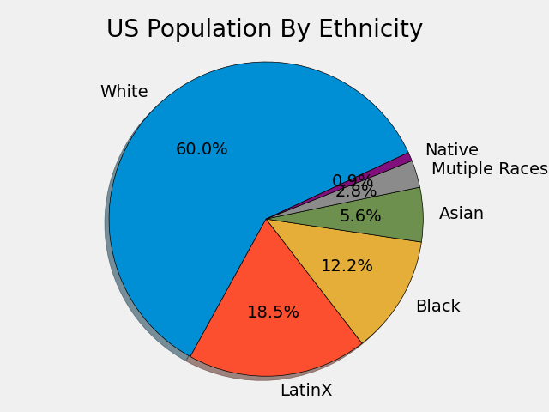

Figure 2 via (https://www.beamjobs.com/diversity/racial-diversity-in-tech)

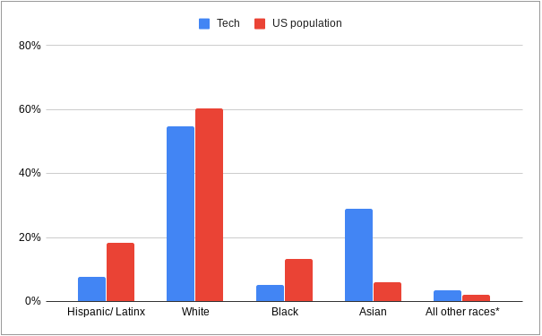

It is interesting to note the over-employment of the “model minority” group Asian as Asian people are hired in Tech grossly above their ratio to the entire population. Stereotyping can be positively applied; however, such application is detrimental to reality and notions of self-representation for Asian ethnic groups.

Figure 3 (via Python Software)

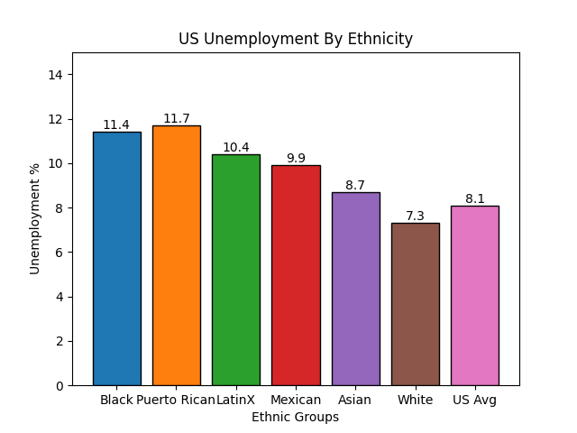

The above chart posits a discrepancy within the United States of America. Black people makeup approximately 13 percent of the population but have the highest unemployment rate, just under people of Puerto Rican descent. According to (Manning 1983), “The logic of the ideological apparatuses of the racist/capitalist state leads inextricably to Black cultural genocide which assists the function of ever-expanding capital accumulation. Unusually high Black unemployment results from these racists and capitalist structures. These structures also make being Black incompatible with being a professional. On the other end of the spectrum, White people who have the highest population in the US have the lowest unemployment numbers even under the US average. Black people in the United States are burdened with the stereotypes of being dangerous, lazy, and unintelligent (Dougherty et al., 2017). This bias is represented in the employment statistics of Black people in all professions and especially in the IT profession. In this country, poorly educated Black men are worse off than women due to high incarceration rates and less university education (Trauth 2013).

Black male students do not graduate with their peers. Only about 47 percent of Black students in 2018 graduated with their peers. Black students are pushed out of school and pipelined into prison. More money in this country goes toward building the prison industrial complex than promoting higher educational achievement in Black males. This pipeline leads to terrible college enrollment rates, a disconnect from the college atmosphere, discouragement, and a low completion rate. Since Black people comprise a significant amount of the US population; this downward trend in education will hurt the nation’s competitiveness globally (KD JOSHI et al 2017). Currently, there are no efforts to change the systematic barriers that prevent Black males from succeeding in higher education. We need a conscious effort to stop the prison pipeline feed and redirect Black males towards success via education and social mobility. Black people equal 9 percent of the workforce but only 2.2 percent in the IT workforce and less than 5 percent at major IT firms. The national and institutional focus should be on getting Black males involved in IT work. If we can encourage Black workers to join the IT field this will solve two problems, the lack of skilled workers in IT and the low Black employment rate.

Most of the research upon Black males features a deficit model of thinking. Even in academia deficit model thinking becomes perpetuated. Society must address the failures of the academy and corporate America as well. An excellent base to help understand the societal structures that prey upon Black males in IT include Critical Race Theory and Pierre Bourdieu’s Capital Theory. According to (KD Joshi 2017) “To expand Black men’s career options, it is necessary first to understand Black men’s career development and choices which, we premise, unfold differently than for Black woman or other ethnic male cohorts.” The Black Experience within IT is often negative.

Frequent encounters occur with security or police when Black IT Professionals leave a building with expensive hardware or devices. We must debunk negative stereotypes which stem from hegemonic forms of Black masculinity. Black youth need reassurance from educators and community support groups that they are capable young men. Society needs to stop having low to substandard academic expectations. The Black experience is compelling. However, other groups often do not acknowledge the effects that racism and stereotypes have on a Black person’s life or career path. Coping with racism and discrimination in the workplace can lead to burnout, stress, and professionals even leaving the IT field altogether.

Ironically enough, the United States of America has been looting Black people of their capital for hundreds of years, starting from chattel slavery concurrently doing away with Black people’s cultural identity. To overthrow the power structure of the United States of America, we must recognize five forms of capital that Black people have at their disposal. These practices include inculcated, structured, durable, generative, and transposable means. Inculcated refers to things that can be learned such as resilience via struggle or a young Black child that sees his parents or mother or father go to work every day. The young man or woman will learn the value of work ethic from viewing their parent or grandparent. Structured capital stems from the social conditions in which people live in. Growing up in an urban neighborhood can help one learn how to deal with difficult situations, cope with poverty, or be resourceful even though supplies and resources are low. Another aspect of capital that can help Black people succeed in IT and in general includes generative practices in which Black people produce multiple skills. Durable methods include techniques or learned skills that last through an induvial life history. Transposable techniques include skills which can be applied in fields other than the field that they were initially intended. In modern times Black people are left out of upper management in tech firms and throughout corporate America due to a lack of social capital or network. Bourdieu defines social capital as follows: “Social capital is the sum of the resources, actual or virtual, that accrue to an individual or a group by virtue of possessing a durable network of more or less institutionalized relationships of mutual acquaintance and recognition.” (Bourdieu, in Bourdieu & Wacquant, 1992: 119). His theory adequately quantifies the nuances of the power struggle between capitalism and the Black male. Every benefit of capitalism towards the privileged group reflects on a system and institution built to exclude Black males from every aspect of the process, from production to skilled professional positions in upper management. The American capitalist system was not built for everyone to succeed but rather the elite who already control the economic preconditions. Why Do Black College Graduates Have a Lower Homeownership Rate Than White People Who Dropped Out of High School? (Choi Goodman 2020)

Application of Bourdieu’s Capital Theory to Myself: IT Professional & University Student

Figure 4 (via www.epicpeople.org/theritualoflean/)

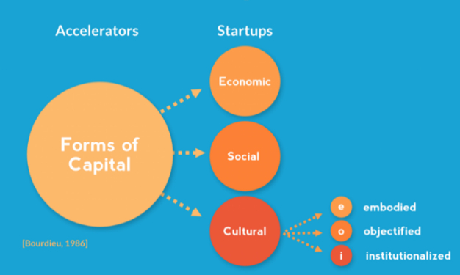

|  |  |
| --- | --- |
| **Economic** | As a student and IT Professional I earn grant money from the federal government due to my student status at CSULA. I also earn money as a contract worker for Wells Fargo. The money I earn can be transferred to others, utilized to pay debts, or purchase private property. |
| **Cultural (3 Subtypes)** | ***Objectified Capital***: Capital that can be passed on or transferred to another individual. In April 2021my father passed on to me a 1997 Cadillac DeVille. Not only did he pass on a physical vehicle, he also passed along an admiration and appreciation for the Cadillac brand of car.  ***Incorporated/Embodied Capital***: My knowledge of IT and troubleshooting computer hardware and software which I learned over the years. This information cannot be passed on because it is learned over time and takes specialization.  ***Institutionalized Capital***: An example of institutionalized capital includes my certification as a Microsoft Technical Associate: Database Administration Fundamentals. Microsoft and the IT community in general acknowledges the certificate as a credible example of my competency using SQL as a Database Administrator. |
| **Social** | At my position at Wells Fargo my point of contact was a Senior Tech Operations Analyst named Alan Nakama. During my work I was able to network with Alan. This network enabled me to utilize Alan as a reference and garner an interview with Wells Fargo for the position of Tech Operations Analyst. |
| **Symbolic** | An example of symbolic capital includes the honor, prestige, and perceived social status of obtaining at degree. In two weeks, I will obtain a bachelor’s degree in Pan-African Studies. Along with this degree comes positive social perceptions and perceived social status by hiring IT firms and other societal entities. |

There are positive and negative aspects of social capital that affect Black males. Some negative social capital factors include a lack of mentors and network resources because of one’s Blackness and possibly lower socio-economic status. Affluent communities often have libraries equipped with better computers and more books on a wide range of topics as opposed to inner-city libraries, which contain fewer resources and have old computers and less technology. Also, the white hegemonic network looks out for people who are either in this network or appear physically the same. Some favorable aspects of social capital for Black people include the resilience and fighting spirit that Black people gain from their ancestors. Black people learn how to manage and cope with trauma amazingly. Despite all the traumatic history and events of the past, Black people are still productive and thriving in society.

There exists a paradox of the Black Professional. People of color face a paradox in trying to maintain a professional existence. The unwritten assumption concerning professionalism in corporate America is that a professional is a white male. Therefore, women and people of color will be unable to be professionals in the capacity recognized by White America. There are many issues in the professional world concerning Black people. Black people are asked to assimilate and conform to white speech, language, and behavior standards. Even having certain hairstyles such as dreadlocks, a natural afro or braids can be deemed as unprofessional in specific corporate environments. According to (Dougherty and Ferguson Jr. 2021) Blackness is dehumanized in White spaces. The closer a Black person move towards whiteness the more human they are perceived to be. Non-Black people only recognize Black people as accepted or deemed creditable when they become white in their tone, demeanor, and actions. Such an expectation is problematic as it is impossible and takes authenticity and self-representation off the table. No one should have to change their nature or spirit to be a part of a corporation or business. Specifically, a Black male cannot become a White male externally or internally. Therefore, the coerced assumption that Black people must assimilate and conform to a professional standard is flawed. This paradox exists due to contradictions emerging, evolving, and immersed in struggle from routinely practiced experiences. These experiences occur when the group in power (white hegemony) forces Black people to utilize language, discourse, and behavior that they are not used to or practice. Therefore, being “professional” in white standards does not come naturally for a Black person. They must act and put on a white mask to fit in and deal with day-to-day interactions from an employer who does not recognize the uniqueness and value of Blackness but instead shuns and does away with Blackness.

The narrative of Jaimie in reference to Family Guy asserts such. Jaimie about Cleveland the character on Family Guy sees himself. Jamie states: it was a Black guy and he was walking out the door. I want to say the meme said, “when you get off work”. And the inside he was, he was inside of suit, the suit was zipped down, about halfway zipped down. On the inside you could see this Black guy, and on the outside, you saw this White suit of a White person. He was like unzipping his White self and coming out as the Black person that he usually is. I could definitely like, I laughed at it because I felt like it was symbolic to how I feel. (Dougherty and Ferguson Jr. 2021)” Jamie laughs off his white mask; however, the more significant issue is not a laughing matter. Black males should not give up their ethnic identity to be employed for a corporation.

Next, we will dissect Black males in the IT profession from the vantage point of The Gender Differences Theory of IT. The theory initially purposed for Women in IT, in a Black male scope deals with the intersection of power relations and how Black males navigate the challenges associated with being Black & underrepresented members of the IT field. Thus understanding a Black male IT professional outside of societal stereotypes includes three constructs that adequately frame Black male IT professionals. The first construct includes Individual Identity, which encapsulates the traits of personal demographic (age, race, ethnicity, nationality, socio-economic status, social class, parenting status). The second construct, Individual Influences, includes (unique characteristics, which include (educational background, personality traits, abilities, personal influences including mentors, role models, experiences with computing throughout life and any other significant life experiences). The third construct Environmental Influences includes (cultural attitudes and values, attitudes about IT in general, attitudes about Black males in IT, attitudes about race and ethnicity related to one’s geographical location or location one lives in and policy influences in that individual’s region or country of residence. According to (Cain 2016) “These constructs provide robust attributes by which to examine aspects of an individual’s background, experiences, and lifestyle. Cain further asserts that adding race and ethnicity to these three constructs will help provide robust and comprehensive attributes to examine Black males in IT.

Figure 5 (via Curtis Cain 2016)

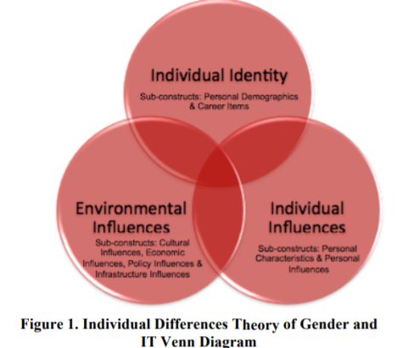

Cain illustrates the intersectionality of each construct via Venn Diagram. When looking at Black males, the Venn Diagram would, in essence, enlarge to include race and ethnicity. (Cain 2016 asserts the importance of higher education in attaining goals related to career placement, self-efficacy, mentors, role models, and institutional support. These various entities help provide Black males with the means to succeed. Black males in IT experience oppression based on gender, race, class, and socio-economic standing, whether low or middle class. This oppression goes back a long way. Sometimes Black males in IT must deal with unsupportive co-workers. Contrast with this oppression features Black males' emancipation when entering IT and performing at a high level. Black males in IT upper management should not be an anomaly. Having Black people, especially Black males in positions of power will provide modeling for young Black youth. Having diverse or even Black-owned firms goes a long way in promoting a more productive and inclusive work environment. When properly introduced to the field of IT with support from mentors, the university institutions, professors, and businesses that seek to employ people of color, the journey of Black males can improve drastically.

**Literature Gaps & Shortcomings**

This literature review features extensive literature concerning the Black male’s participation in the IT industry. Gaps in the literature exist in a few areas. I did not find any literature discussing the issues in the education system of Black children in STEM areas within the primary school. Much of the literature focused on high school and university. In this literature review, I acknowledged some issues that affect Black males en route to an IT profession. However, I did not explain how to change or remedy the structures that limit Black participation in the IT industry.

**Conclusion**

In summation, the issue of Black participation in the IT industry is a vital issue for the Black community. This literature review utilized the theoretical assumptions of Critical Race Theory, the Individual Differences Theory of IT, and Pierre Bourdieu’s Capital Theory to analyze and dissect how Black male professionals in IT navigate societal racism, structural boundaries, and corporate rules. After overcoming so many obstacles, Black males in IT are still productive beyond their IT peers. The job is not finished, however. Much more focus must be placed on STEM proficiency in inner-city Black communities, whether through mentorships, tutorial non-profit organizations, or university and high school outreach programs; the battle has just begun. It is the responsibility of every member of society, including government institutions of education, local government employment agencies, and lobbyist, to change the inequality and lack of diversity within the IT field. The only way to change is to work together and build a better outcome for the next generations of STEM students and professionals

**REFERENCES**

A. Buzzetto-More, N., Ukoha, O., & Rustagi, N. (2010). Unlocking the Barriers to Women and Minorities in Computer Science and Information Systems Studies: Results from a Multi-Methodical Study Conducted at Two Minority Serving Institutions. *Journal of Information Technology Education: Research*, *9*, 115–131.

Bourdieu, P. (2002). Forms of Capital. *Journal of Economic Sociology*, *3*(5), 60–74.

Cain, C. C., & Trauth, E. M. (2016). Black Lives Matter: The Journey of a Black IT Scholar Proceedings of the 2016 ACM SIGMIS Conference on Computers and People Research.

Cain, C.C., Trauth, E.M. (2012). "Black Males in IT Higher Education in The USA: The Digital Divide in the Academic Pipeline Re-visited," Proceedings of the 18th Americas Conference on Information Systems (Seattle, WA).

Cain, C.C., Trauth, E.M. (2013). "Stereotype Threat: The Case of Black Males in the IT Profession," Proceedings of the 2013 ACM SIGMIS-CPR (Cincinnati, OH)

Cain, C. C., & Trauth, E. (2015). Theorizing the underrepresentation of Black males in information technology (IT). In 2015 Americas Conference on Information Systems, AMCIS 2015 (2015 Americas Conference on Information Systems, AMCIS 2015). Americas Conference on Information Systems.

Cain, C.C. (2012). "Underrepresented Groups in Gender and STEM: The Case of Black Males in CISE," Proceedings of the 2012 ACM SIGMIS-CPR (Milwaukee, WI).

Choi, J. H., & Goodman, L. (2020, February 27). *Why Do Black College Graduates Have a Lower Homeownership Rate Than White People Who Dropped Out of High School?* Urban Institute. https://www.urban.org/urban-wire/why-do-black-college-graduates-have-lower-homeownership-rate-white-people-who-dropped-out-high-school

‌

Ferguson, M. W., & Dougherty, D. S. (2021). The Paradox of the Black Professional: Whitewashing Blackness through Professionalism. *Management Communication Quarterly*, 089331892110197.

Franklin, A., Veeramani, V., Suprise, M., & Woodward, B. (2020). Underrepresented Students’ Confidence in Information Technology Content Areas. *Proceedings of the 21st Annual Conference on Information Technology Education*.

Greet, S. (2020). *Racial Diversity In Tech By The Numbers*. www.beamjobs.com. https://www.beamjobs.com/diversity/racial-diversity-in-tech

Haines, J. (2014, December 22). *The Ritual of Lean*. EPIC. https://www.epicpeople.org/the-ritual-of-lean/

Joshi, K., Trauth, E., Kvasny, L., Morgan, A. J., & Payton, F. C. (2017). Making Black Lives Matter in the Information Technology Profession. *ACM SIGMIS Database: The DATABASE for Advances in Information Systems*, *48*(2), 21–34.

Kvasny, L., Trauth, E. M., & Morgan, A. J. (2009). Power relations in IT education and work: the intersectionality of gender, race, and class. *Journal of Information, Communication and Ethics in Society*, *7*(2/3), 96–118.

Mullins, M. (2017, June 22). *America is Still the Land of Opportunity*. https://mullin.house.gov/news/documentsingle.aspx?DocumentID=612

Sisco, S. (2020). Race-Conscious Career Development: Exploring Self-Preservation and Coping Strategies of Black Professionals in Corporate America. *Advances in Developing Human Resources*, *22*(4), 419–436.

Taylor, V. E. (2010). Cultivating cultural diversity in information technology. *Communications of the ACM*, *53*(7), 35–36.

Trauth, E. (2017). A Research Agenda for Social Inclusion in Information Systems. *ACM SIGMIS Database: The DATABASE for Advances in Information Systems*, *48*(2), 9–20. https://doi.org/10.1145/3084179.3084182

‌

Trauth, E., Joshi, K. D., & Yarger, L. K. (2018). ISJ Editorial. *Information Systems Journal*, *28*(6), 989–994.

Trauth, E.M., Cain, C.C., Joshi, K.D., Kvasny, L. and Booth, K. (In Review). "The Influence of Gender Ethnic Intersectionality on Gender Stereotypes about IT Skills and Knowledge,” The DATA BASE for Advances in Information Systems

Wacquant, L., & Akçaoğlu, A. (2017). Practice and symbolic power in Bourdieu: The view from Berkeley. *Journal of Classical Sociology*, *17*(1), 55–69.

Washington, A. N., Burge, L., Mejias, M., Jean-Pierre, K., & Knox, Q. (2015). Improving Undergraduate Student Performance in Computer Science at Historically Black Colleges and Universities (HBCUs) through Industry Partnerships. *Proceedings of the 46th ACM Technical Symposium on Computer Science Education*.

Wingfield, A. H., & Wingfield, J. H. (2014). When visibility hurts and helps: How intersections of race and gender shape Black professional men’s experiences with tokenization. *Cultural Diversity and Ethnic Minority Psychology*, *20*(4), 483–490.

Woszczynski A., Beise, C., Myers, M., & Moody, J. (2003). Diversity and the information technology workforce. *Proceedings of the 2003 SIGMIS Conference on Computer Personnel Research Freedom in Philadelphia--Leveraging Differences and Diversity in the IT Workforce - SIGMIS CPR ’03*.

‌Zamudio, M., Russell, C., Rios, F., & Bridgeman, J. L. (2010). *Critical Race Theory Matters: Education and Ideology* (1st ed.). Routledge.